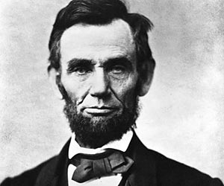Hispanic Heritage Month Presentation

**Objective:** *Create a PowerPoint presentation or Prezi about a famous Latino or Hispanic.*

1. Decide whose biography you will do research on. Your person should be someone who has contributed something of importance to society or history and has become famous because of it.

**Have this person approved!**

1. 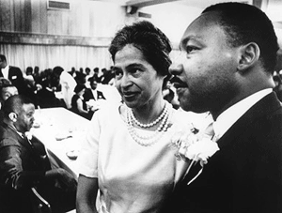Create an 8-slide PowerPoint presentation or 8 Prezi slides about the person you have chosen to research.

***Slide 1:*** Introduction Slide

***Slide 2:*** Background Information

* Where/when was this person born?
* Childhood

***Slide 3:*** Becoming Famous

* What did this person do for a living?
* What qualities or traits do you believe made this person famous?
* What did this person do to become famous?

***Slide 4:*** Impact on Others

* How has this person made an impact on others’ lives?
* In what ways was his/her life remarkable, admirable, or even despicable?
* Was this person a hero? Why or why not?

***Slide 5:*** Decisions/Lessons

* Did this person make any major mistakes or bad decisions?
* What are some important lessons you or any other person might learn from the way this person lived?

***Slide 6:*** Quotes

* Famous quotes from this person
* What do the quotes mean to you?

***Slide 7:*** Other/Your choice

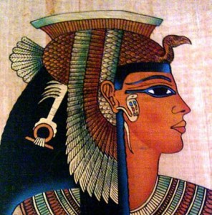

***Slide 8:*** Sources

1. You must have pictures ON EACH SLIDE! Pictures must be clear and appropriate. They must add to the purpose and design of the slides.
2. Slides should be clear, easy to read, and well balanced.
3. Correct spelling/grammar

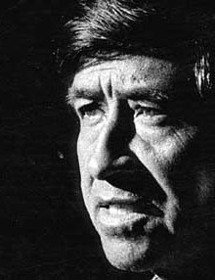

1. Present to class:

* Speak clearly
* Explain each slide thoroughly
* Make it easy to understand

1. This project is due on October 4th 2018. You will be given 2 days to work on it in the library.
2. To submit your powerpoint go to [www.SrRivera.weebly.com/enlaces](http://www.SrRivera.weebly.com/enlaces). Click on your class period and upload the powerpoint saved with your name. Ej, Sr.Rivera.pptx. If you made a prezi be ready to login to your account when you have to present.

RUBRIC

|  |  |  |
| --- | --- | --- |
| Creativity | Presentation was engaging, interesting, and created curiosity. | /10 |
| Content | You brought your topic to life with complete, thorough, and **appropriate** information. | /10 |
| Visual | Your visual was well crafted and helped the class understand your information. | /10 |
| Presentation | Presentation was well given. You understood the material and spoke clearly to the audience. | /10 |
| Use of Tools | You demonstrated proper use of PowerPoint/Prezi tools. (Formatting, Animation, Transitions, etc.) | /10 |
| Total | | /50 |

